K SANDHIYA(192521378)
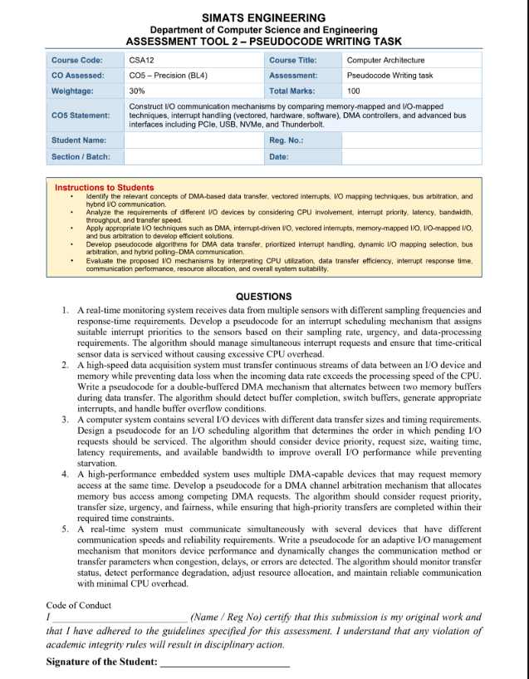

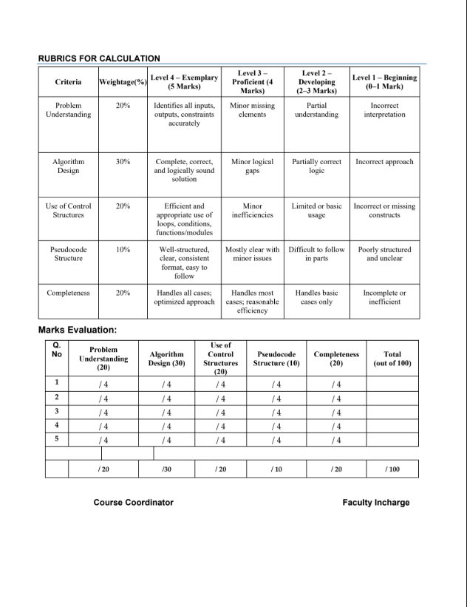

1. Real-Time Interrupt Scheduling Mechanism
Objective: Assign interrupt priorities according to sampling rate, urgency, and processing requirements, while avoiding excessive CPU overhead.
ALGORITHM RealTimeInterruptScheduler
INPUT:
Sensors = {S1, S2, ..., Sn}
For each sensor Si:
sampling_rate[Si]
urgency[Si]
processing_time[Si]
deadline[Si]
interrupt_pending[Si]
BEGIN
FOR each sensor Si DO
// Calculate priority score
rate_score = Normalize(sampling_rate[Si])
urgency_score = Normalize(urgency[Si])
processing_score = Normalize(processing_time[Si])
deadline_score = CalculateDeadlineUrgency(deadline[Si])
priority[Si] =
W1 * rate_score
+ W2 * urgency_score
+ W3 * deadline_score
+ W4 * processing_score

IF priority[Si] > MAX_PRIORITY THEN
priority[Si] = MAX_PRIORITY
END IF

END FOR
WHILE system_is_running DO
IF interrupt_request_received THEN
Add requesting sensors to InterruptQueu
// Sort highest priority first
Sort InterruptQueue by:
1. Priority (highest first)
2. Earliest deadline
3. Waiting tim
WHILE InterruptQueue is not empty DO
S = RemoveHighestPriority(Interrup
Disable lower-priority interrupts tem
ServiceInterrupt(S
ReadSensorDat
StoreDataInBuffer(S)

IF ProcessingRequired(S) THEN
ScheduleProcessing(S)
END IF

ClearInterruptFlag(S)

RestoreInterruptState()

END WHILE

END IF

// Avoid unnecessary polling
CPU enters low-power/idle state
until next interrupt or timer event

END WHILE

END
Key points
- Sensors with higher sampling rates and greater urgency receive higher priority.
- Deadline-based scheduling ensures time-critical data is handled first.
- Interrupts are queued when several sensors request service simultaneously.
- CPU overhead is reduced by using interrupt-driven operation instead of continuous polling.
- Lower-priority processing can be postponed when a critical interrupt arrives.
2. Double-Buffered DMA Mechanism
Objective: Continuously transfer data between an I/O device and memory using two buffers so that one buffer can be processed while the other receives new data.
ALGORITHM DoubleBufferedDMA

INPUT:
BufferA
BufferB
DMA_Controller
IO_Device

BEGIN

Initialize BufferA
Initialize BufferB

active_buffer = BufferA
processing_buffer = BufferB

Configure DMA_Controller with active_buffer

Start DMA transfer from IO_Device
to active_buffer

WHILE system_is_running DO

IF DMA_Transfer_Complete THEN

Mark active_buffer as FULL

Generate DMA_COMPLETE_INTERRUPT

// Switch buffers
temp = active_buffer
active_buffer = processing_buffer
processing_buffer = temp

IF active_buffer is EMPTY THEN

Configure DMA_Controller
with active_buffer

Restart DMA transfer

ELSE

// Both buffers are full
Generate BUFFER_OVERFLOW_WARNING

Stop or temporarily throttle input

HandleOverflow()

END IF

// Process previously completed buffer
IF processing_buffer is FULL THEN

ProcessData(processing_buffer)

Clear processing_buffer

Mark processing_buffer as EMPTY

END IF

END IF

IF BUFFER_OVERFLOW_DETECTED THEN

Generate OVERFLOW_INTERRUPT

Reduce input rate if possible

Increase processing priority

IF possible THEN
Increase buffer size
END IF

IF data loss is unavoidable THEN
RecordLostData()
END IF

END IF

END WHILE

END
Working principle
I/O Device
|
v
+---------+ +---------+
| Buffer A| <---> | Buffer B|
+---------+ +---------+
| |
v v
DMA Transfer CPU Processing
While Buffer A is being filled by DMA, the CPU processes Buffer B. After Buffer A is full, DMA switches to Buffer B and the CPU processes Buffer A.
This minimizes data loss and allows continuous data acquisition.
3. I/O Scheduling Algorithm
Objective: Select the next I/O request by considering priority, request size, waiting time, latency, and available bandwidth while preventing starvation.
ALGORITHM IOScheduler

INPUT:
PendingRequests = {R1, R2, ..., Rn}

For each request Ri:
device_priority[Ri]
request_size[Ri]
waiting_time[Ri]
latency_requirement[Ri]
required_bandwidth[Ri]

BEGIN

WHILE PendingRequests is not empty DO

FOR each request Ri in PendingRequests DO

priority_score =
W1 * Normalize(device_priority[Ri])
+ W2 * Normalize(waiting_time[Ri])
+ W3 * Normalize(1 / latency_requirement[Ri])
+ W4 * Normalize(required_bandwidth[Ri])
- W5 * Normalize(request_size[Ri])

// Prevent starvation
IF waiting_time[Ri] > STARVATION_LIMIT THEN
priority_score =
priority_score + STARVATION_BOOST
END IF

IF latency_requirement[Ri] is CRITICAL THEN
priority_score =
priority_score + DEADLINE_BOOST
END IF

score[Ri] = priority_score

END FOR

// Select request with highest score
R = RequestWithMaximumScore(PendingRequests)

// Check available bandwidth
IF AvailableBandwidth >= required_bandwidth[R] THEN

Remove R from PendingRequests

StartIOTransfer(R)

Wait until transfer completes

UpdateDeviceStatistics(R)

ELSE

// Bandwidth insufficient
Find another request that can be serviced

IF another suitable request exists THEN
R = SelectNextRequest()
StartIOTransfer(R)
ELSE
WaitForBandwidth()
END IF

END IF

// Update waiting times
FOR each remaining request Ri DO
waiting_time[Ri] =
waiting_time[Ri] + elapsed_time
END FOR

END WHILE

END
Important features
- Device priority handles important devices first.
- Waiting time increases priority over time.
- Latency requirements give urgent requests faster service.
- Request size and bandwidth are considered for efficient transfers.
- Starvation prevention is achieved using aging/starvation boosting.
4. DMA Channel Arbitration Mechanism
Objective: Decide which DMA device gets memory-bus access when multiple devices request it simultaneously.
ALGORITHM DMAChannelArbitration

INPUT:
DMA_Requests = {D1, D2, ..., Dn}

For each request Di:
priority[Di]
transfer_size[Di]
urgency[Di]
waiting_time[Di]
deadline[Di]

BEGIN

WHILE DMA_Requests are pending DO

FOR each Di in DMA_Requests DO

urgency_score =
CalculateUrgency(deadline[Di])

fairness_score =
Normalize(waiting_time[Di])

size_score =
CalculateTransferEfficiency(transfer_size[Di])

arbitration_score =
W1 * priority[Di]
+ W2 * urgency_score
+ W3 * fairness_score
+ W4 * size_score

// Prevent starvation
IF waiting_time[Di] > MAX_WAIT_TIME THEN
arbitration_score =
arbitration_score + FAIRNESS_BOOST
END IF

score[Di] = arbitration_score

END FOR

// Select DMA request
D = RequestWithMaximumScore(DMA_Requests)

GrantMemoryBus(D)

StartDMATransfer(D)

Transfer data for:
MIN(transfer_size[D], MAX_BURST_SIZE)

ReleaseMemoryBus(D)

Update waiting times of other requests

IF transfer of D is complete THEN
Remove D from DMA_Requests
ELSE
Keep D in DMA_Requests
END IF

IF HighPriorityDeadlineIsNear() THEN
IncreasePriorityOfUrgentRequests()
END IF

END WHILE

END
Explanation
The arbitration mechanism uses a weighted priority score:
Arbitration Score =
Priority
+ Urgency
+ Waiting Time
+ Transfer Efficiency
A high-priority and urgent DMA request gets the bus quickly, while the waiting-time factor prevents low-priority devices from starving.
The use of a maximum burst size also prevents one DMA device from monopolizing the memory bus.
5. Adaptive I/O Management Mechanism
Objective: Dynamically change communication parameters when congestion, delays, or errors occur while maintaining reliable communication with low CPU overhead.
ALGORITHM AdaptiveIOManager

INPUT:
Devices = {D1, D2, ..., Dn}

For each device Di:
communication_mode[Di]
transfer_size[Di]
baud_rate_or_speed[Di]
error_count[Di]
latency[Di]
throughput[Di]
retry_count[Di]

BEGIN

Initialize communication parameters

WHILE system_is_running DO

FOR each device Di DO

// Monitor device
status = CheckTransferStatus(Di)

Measure:
latency[Di]
throughput[Di]
error_count[Di]
queue_length[Di]

IF status == ERROR THEN

error_count[Di]++

IF retry_count[Di] < MAX_RETRIES THEN

retry_count[Di]++

RetryTransfer(Di)

ELSE

// Communication quality is poor
ReduceTransferSize(Di)
ReduceCommunicationSpeed(Di)

IF AlternativeModeAvailable(Di) THEN
SwitchCommunicationMode(Di)
END IF

ResetRetryCount(Di)

END IF

ELSE IF latency[Di] > LATENCY_LIMIT THEN

ReduceTransferSize(Di)

IncreaseDevicePriority(Di)

AllocateMoreCPU/DMAResources(Di)

ELSE IF queue_length[Di] > CONGESTION_LIMIT THEN

// Congestion detected
ReduceInputRate(Di)

EnableDMAIfAvailable(Di)

IncreaseBufferSizeIfPossible(Di)

ELSE IF throughput[Di] < MIN_THROUGHPUT THEN

AdjustTransferParameters(Di)

IF AlternativeCommunicationModeAvailable(Di) THEN
SelectMoreEfficientMode(Di)
END IF

ELSE

// Normal operation
MaintainCurrentParameters(Di)

END IF

// Recover performance when conditions improve
IF PerformanceImproved(Di) THEN

GraduallyIncreaseTransferSize(Di)
GraduallyIncreaseCommunicationSpeed(Di)

IF BetterModeAvailable(Di) THEN
SwitchToBetterMode(Di)
END IF

END IF

END FOR

// Avoid continuous CPU polling
SleepUntil:
TimerEvent OR
DMAInterrupt OR
IOInterrupt OR
ErrorEvent

END WHILE

END
Main features
- Performance monitoring: Tracks throughput, latency, errors, and queue length.
- Congestion detection: Reduces input/transfer rate when buffers or queues become overloaded.
- Error handling: Retries failed transfers and changes communication parameters after repeated failures.
- Dynamic resource allocation: Gives additional DMA/CPU resources to devices experiencing critical delays.
- Adaptive transfer size: Uses smaller transfers during congestion and larger transfers when conditions improve.
- Low CPU overhead: Uses interrupts, DMA, and timer-based monitoring rather than continuously polling every device.
- Reliability: Retransmission and fallback communication modes help prevent data loss.

